Music for Mental Health
Project Information 2023/24

Research has shown that music can have a positive effect on mental health, and working with others on creative pursuits is one of the ‘Five Ways to Wellbeing’ championed by the World Health Organisation.

If you’re experiencing mental health or wellbeing challenges, you are warmly invited to join musicians from the Royal Philharmonic Orchestra for fun, creative music sessions to listen to and create music alongside professional musicians. Sessions are evidence-based and designed to provide respite and improve mood, delivered by our specially trained musicians and Workshop Leaders.
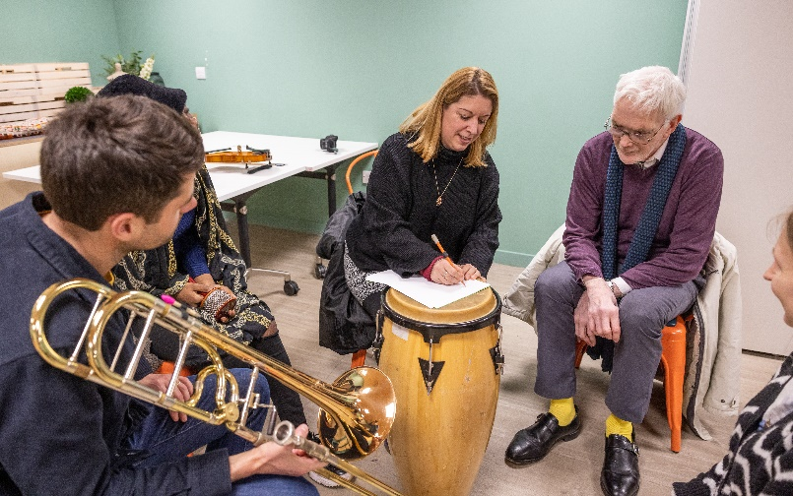
At each session, you’ll get the chance to meet professional musicians and work together with other participants to create brand new pieces of music and song. You’ll be supported to try out instruments, and devise melodies, lyrics, rhythms and styles for your pieces, expressing your thoughts, feelings and emotions.

No prior musical experience is required to take part and all genres or types of music are welcome to be explored. Instruments will be provided, but feel free to bring your own if you already play. Drop in to one session to try it out, or sign up for multiple.

Register Now
Sessions are free but spaces are limited. To register, please complete the form overleaf and return to Resound@rpo.co.uk to secure your place.

Music for Mental Health: Project Registration
Thank you for your interest in our music and mental health project. Please complete the following questions and return to Resound@rpo.co.uk or ring 07809 322 401 for help.

- Name: _______________________________________________
- Contact phone number: ____________________________________________
- How did you hear about the sessions? (Please list the service or group who suggested the project to you, if applicable.)

_____________________________________________________________
- Demographics (We use this information to compile statistical data about our project as required by our funders, and to ensure sessions are safe and appropriate for all participants. No names or identifying details will be shared.)

Age: ☐ 18-64 years ☐ 65+ years
Ethnicity: _____________________________________________________

Disability/Access Needs: _________________________________________________________
_______________________________________________________________________________
- Please tick which session(s) you wish to attend:
☐ Monday 16th October 2023, 16:00-17:15 at Ashford Place, Cricklewood, NW2 6TU
☐ Monday 16th October 2023, 17:30-18:45 at Ashford Place, Cricklewood, NW2 6TU
☐ Monday 13th November 2023, 16:00-17:15 at The Yellow, Wembley Park, HA9 0GL
☐ Monday 13th November 2023, 17:30-18:45 at The Yellow, Wembley Park, HA9 0GL
☐ Tuesday 12th December 2023, 16:00-17:15, Brent Hub, 6 Hillside, Harlesden, NW10 8BN
☐ Tuesday 12th December 2023, 17:30-18:45, Brent Hub, 6 Hillside, Harlesden, NW10 8BN
☐ Monday 15th January 2024, 16:00-17:15 at Ashford Place, Cricklewood, NW2 6TU
☐ Monday 15th January 2024, 17:30-18:45 at Ashford Place, Cricklewood, NW2 6TU
☐ Monday 12th February 2024, 16:00-17:15, Brent Hub, 6 Hillside, Harlesden, NW10 8BN
☐ Monday 12th February 2024, 17:30-18:45, Brent Hub, 6 Hillside, Harlesden, NW10 8BN
☐ Monday 18th March 2024, 16:00-17:15 at The Yellow, Wembley Park, HA9 0GL
☐ Monday 18th March 2024, 17:30-18:45 at The Yellow, Wembley Park, HA9 0GL

Privacy Statement
The Royal Philharmonic Orchestra (RPO) takes the responsibility of handling your personal data seriously. The Orchestra respects your privacy and we are committed to ensuring proper use of data and that only relevant information is processed according to your wishes.
We use the personal information held about you in accordance with the Data Protection Act 1998, the Privacy and Electronic Communications Regulations 2003, any replacement laws and the Global Data Protection Regulation (GDPR).
We will only store and use data supplied in this form for the purposes of carrying out our Music for Mental Health project sessions as indicated.For more information about the RPO’s privacy and data protection policies or to register a complaint or question, please email data@rpo.co.uk.

